Bill Spurgeon
7961 Wilderness Way
Ooltewah, TN 37363

Bill,
Please find enclosed, $9.00 to cover postage for the “thingee” we have discussed on the Ford V-8 web page.

Mail it to, George Maher, 702 27th Street North, Fargo, North Dakota 58102 (701-866-4607).

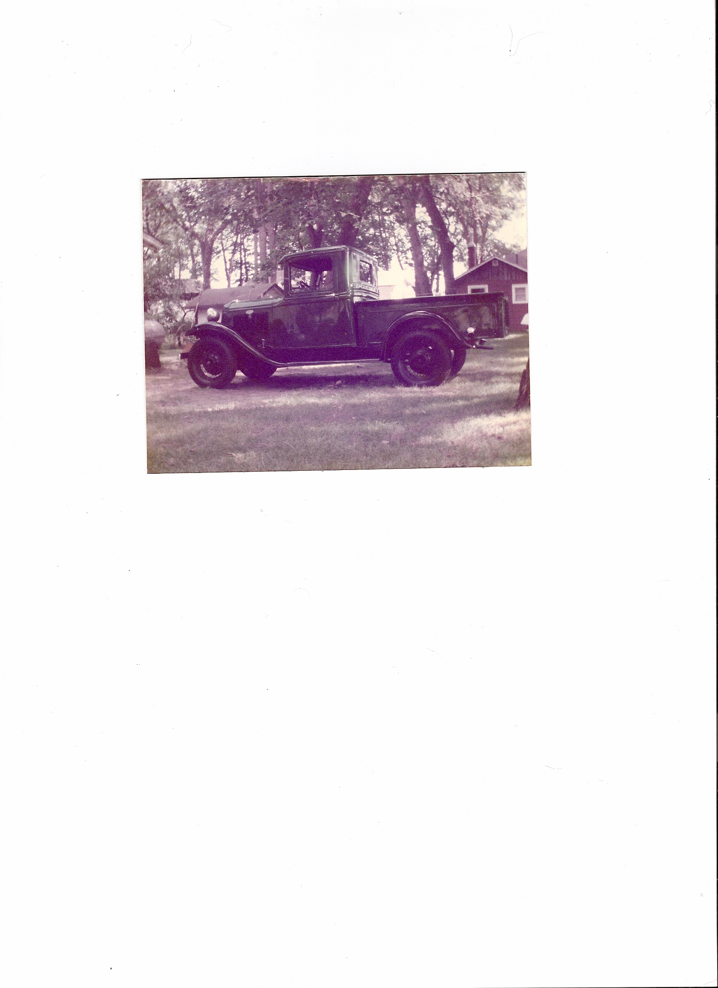
Thanks, George

