1949 Mercury Convertible Restoration Part 69

August 3rd, 2010 Posted by: Steve --> · No Comments
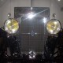
We still don’t know what the word “special” written on the back of the dash means. We still felt it was important to put it back on the dash. Probably because it is a mystery. It was written with white chalk and as soon as we started handling the dash panel the lettering started to quickly fade. We made a quick paper template of the word so that we could put it back on during the assembly. The template was just a quick tracing with some masking paper.
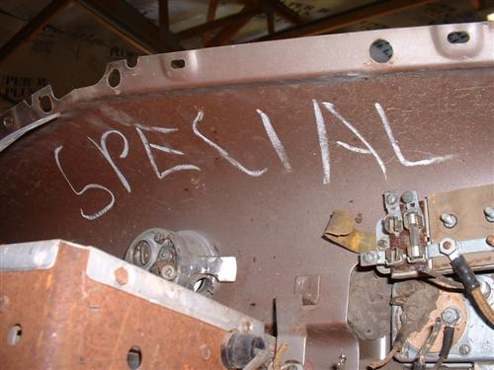
The word “special” written in chalk on the back of the dash panel.
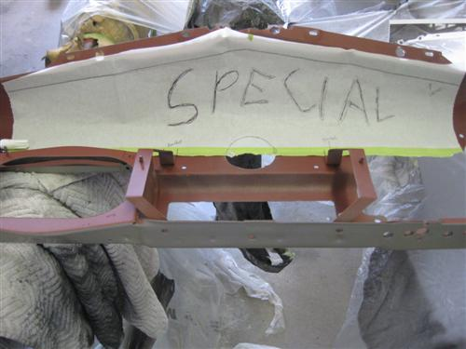
Paper tracing of the lettering before the dash was stripped.
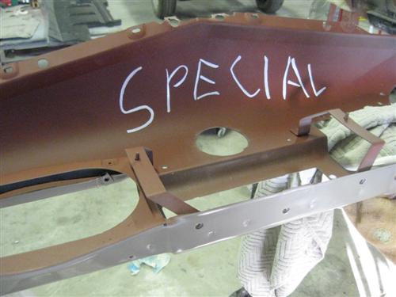
This is the new lettering done with a white paint pen. Note the back of the dash was painted with red Zero-Rust so it would match the original red oxide primer as in the picture above.
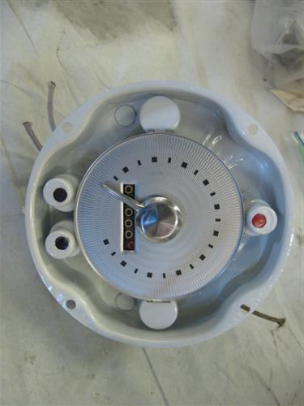
The speedometer was taken apart and cleaned. The inside of the speedometer case was bead blasted and repainted white.
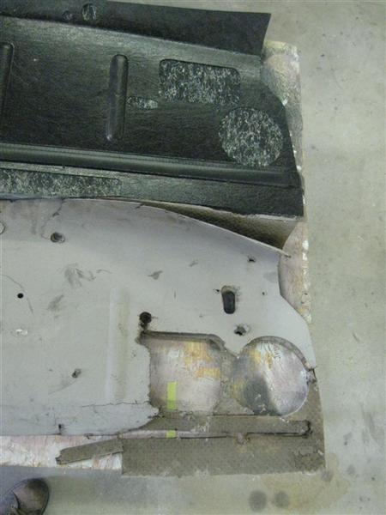
A new firewall pad was purchased from Classic Mercury. It was not exactly correct for the car. The large square heater hole was in the wrong place. I had to do some cutting and pasting with the plastic covering.
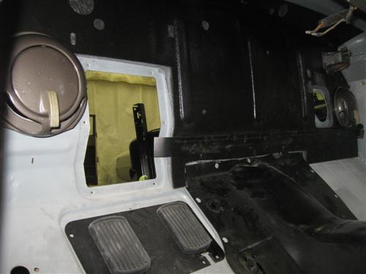
The new firewall pad installed in the car.

