Ball Bearing Fan Hub
By MAS Automotive & Machine
54 Commercial Ct.
Iowa City IA 52246

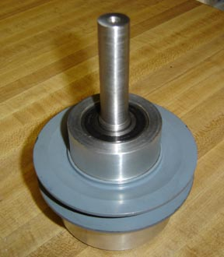
We developed the ball bearing fan hub for our own 1947 Ford to replace the stock troublesome oil reservoir unit. It is constructed of billet aluminum with sealed high speed ball bearings. It is installed into the stock bracket of the 1942-48 V-8 engine Part # 21A-8632 with no modification, and accepts the standard 8 bolt fan blade. These are hand made, limited production items and available on an irregular basis. Current price is $350.00 + UPS shipping. Due to increasing material costs, this price is subject to change without notice.
