Flathead Ford Repair

As Ford flathead blocks become even more scarce and expensive, we are taking extra measures to keep them in service. These include MagnaFlux inspection using special equipment, drilling and pinning cracks when possible, and restoring all surfaces.. Many otherwise sound blocks can be bored and sleeved, and hard valve seats installed. Below, we show examples of this type of true rebuilding to restore these engines.

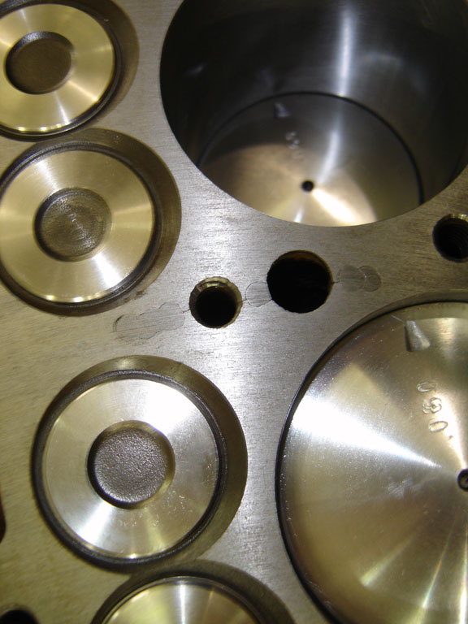

Look carefully. You will see that we have repaired the commonly found cracks in the valve area, and the lesser important ones in the water jacket surface, which may later spread if not addressed. See also new valves and seats, including stainless steel for expanded valve durability.

All photographs taken at MAS Automotive and Machine, 54 Commercial Ct. Iowa City, Iowa.

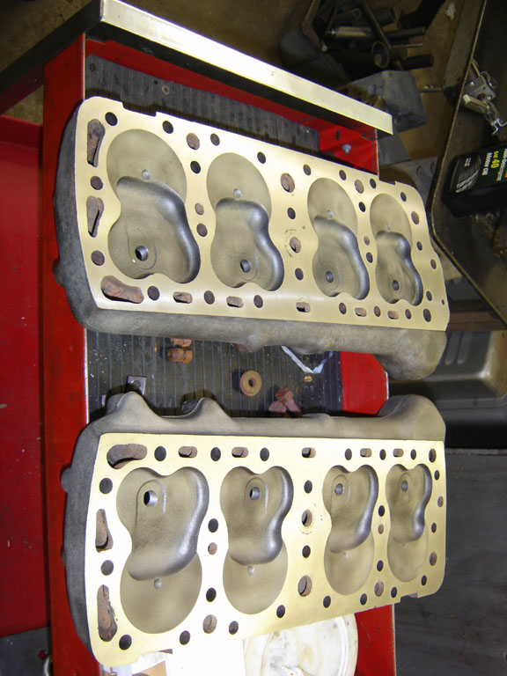

It is important to inspect the cylinder heads for cracks and warping, then mill a fresh surface to ensure gasket sealing., a process often overlooked.

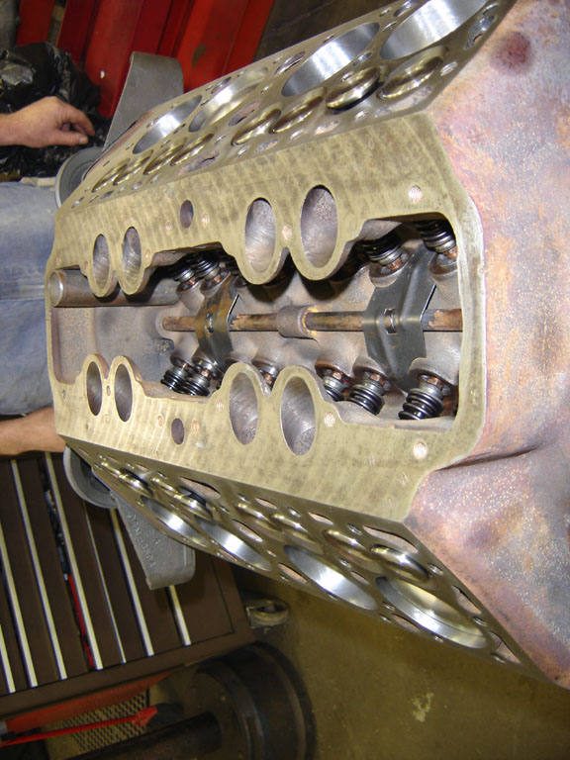

Once the cylinders are bored and honed, the engine is reassembled with adjustable lifters, new bearing inserts, and a fully balanced crankshaft, rods and pistons. Note the very clean block.