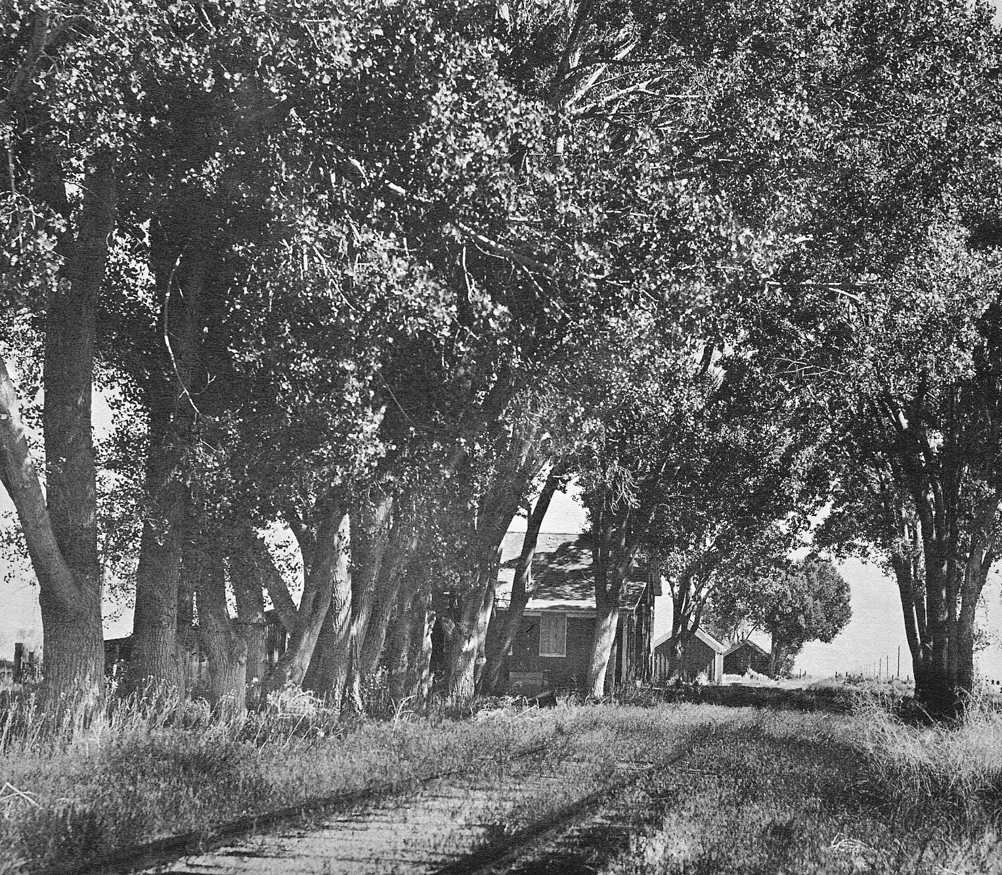
LONG AGO AND FAR AWAY …. STEWART, NEVADA …. Page 1

Around the 1940’s photographer Charles M. Clegg (1916-1979) visited a small hamlet named Stewart on the old Carson City-Minden Branch of the Virginia & Truckee Railroad. The Branch was built in 1907, running only 12 miles south from Carson City to the Town of Minden. It carried local dairy products and mail.

Here at Stewart, beneath a larger grove of enormous Nevada Cottonwoods, Clegg found abandoned and disintegrating buildings …. a Section House, Coachyard (for storage of passenger coaches), Workshops and Turntable with Roundhouse. The building in the near foreground, adjacent to the track, was the “Section House” where workers lived.

The line would see its demise in the 1960’s, it’s rail bed replaced by a modern highway. This place, the trees and buildings, and the Hamlet of Stewart, now only exist within photographs. It would have been nice to picnic in this grove of trees on a hot afternoon, waiting for the next train to rumble, hiss and smoke on-by.

